Rachamim-Yair Brito
Statistical Ecology
Dr. Brian Maitner
12/11/2025
Final
Introduction:
Ecology is an important sect of the biological sciences that allows us to understand how biotic and abiotic factors affect various environments and the species within them. A particular aspect of ecology that has had historical significance is avian ecology; with certain journals like The Auk and organizations like The Audubon Society having a historical focus on birds. Birds are widely seen as means for pest control, seed dispersal/pollination, they are indicator species, environmental engineers and all around important for the ecosystems they inhabit including coral reefs (BirdLife International, 1). All of these are examples of why birds and especially bird biodiversity is integral to the health of our ecosystems; therefore, understanding how different factors affect said diversity can provide insight into what actions may need to be taken to assure the health of our avian companions.
Accessible via USGS, Ziolkowski et. al. (2) had compiled bird data from 1966 to 2021, looking at many different routes, across numerous years, noting what species were seen there and at what frequency alongside other variables like mean annual precipitation (MAP), mean annual temperature (MAT), fraction built, and total species count amongst others. Data like this is integral in gaining a statistical understanding of how the avian communities at these locations change over time, and how the aforementioned factors may affect them. This is of particular interest since humans are known to be the cause of over 1400 bird species having gone extinct (The Wildlife Society, 3). All of this culminates to the importance of the statistical analyses conducted for this paper. The breadth of data collected by Ziolkowski et. al. allows for an abundance of statistically significant questions to be asked. For the sake of this paper, the questions focused on are: What is the distribution of bird Orders throughout the study period (1996-2019) with respect to Total sightings and mean total sightings, how does MAP, MAT and fraction built affect the total species seen, and finally is there a relationship between MAT and MAP. The results this paper will find can help people understand how various things affect bird biodiversity,
The importance of these statistical analyses is to create a framework for additional more complex questions to be asked, for instance, how do the variables in the data affect the total sightings of individual birds at each route. Although these relationships are something important to look at, due to time constraints this paper will strictly focus on providing broader example codes in R for each aforementioned question, that can later be reran by changing or adding the appropriate filters and pipes for each Route and Year. The reason this paper focuses on determining if MAP, MAT, fraction built, are a function for determining Total species is because it can provide an overarching understanding of how Total species can be affected by multiple variables, and one could then reformat the code to look at how total sightings, or even how populations of specific orders or even species of birds changes.

Materials and Methods:
The data for this paper originated from Ziolkowski et. al. (2)’s paper but was personally obtained from Dr. Brian Maitner’s GitHub (4), where he included additional spatial data such as: Mean annual temperature (MAT), Mean annual precipitation (MAP), and Fraction built, amongst others. RStudio (5) was utilized to run all statistical analyses found in this paper. The following packages within R were also used to help run the analyses and create the figures that will later be shown: ggplot2, bbmle, tidyr, readr, reshape, gplots, plotrix, dplyr, lattice, and e1071 (6-15 respectively). Finally, ChatGPT (16) and the book “Ecological Models and data in R” (17) were used to help understand why certain errors in the code occurred, as well as providing a direction for what code to use to perform the analyses, and how to interpret them. The model used for this paper had Total species as the response variable, and MAT, MAP, fraction built, and Year as the predictor variables (with all of the predictors having an interaction with each other). The type of analyses performed here were: 1) a histogram looking at the distribution of tspp, 2) Two bar charts, one looking at the Order distributions of the whole survey period with respect to Total sightings and one with respect to mean total sightings, and 3) Scatter plots looking at the relationship between Year and Total Species (tspp), Order and tspp, Order and mean tspp, MAP and mean tspp, MAT and mean tspp, MAT and MAP, fraction built and mean tspp, and fraction built and MAT. Pearson correlation tests were also ran for each relationship to note statistical significance.
For all of the statistical analyses, piping was used to home in on the specific part of the data that was of interest. Summary statistics such as the function summary() and str() were done to gain an understanding of the data structure, and class() was used to check if the variables of interest were the appropriate class, if they were not, they were reclasses using the as.numeric() function for example.

Results:
The Florida Breeding Bird Survey data was read into RStudio via this code:
Due to the size of all the potential predictor variables, they were rescaled so models could be created, na.omit was used to eliminate the NAs in the data set. The code used for the rescaling was:
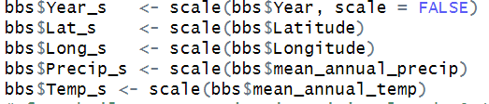
frac_built did not need to be rescaled due to the values already being between 0 and 1.
Multiple models were compared, and the model with Year, MAP, MAT, frac_built, Latitude and Longitude as the predictor variables, all of which had interactions with each other, had the best AIC score, however that seemed confusing to analyze so the model used for this paper was the following:
Keeping this model in mind, the first analysis done was a histogram looking at the distribution of Total Species, the histogram was coded as follows:
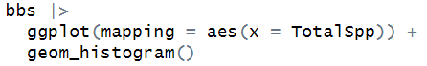
And yielded the following histogram:
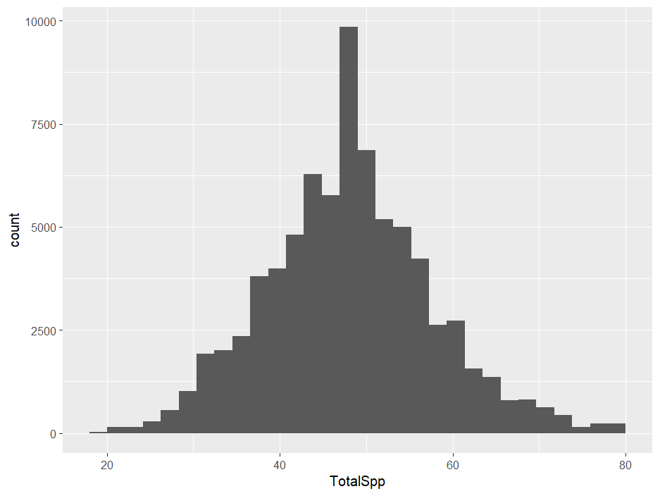
Figure 1: Histogram showing the distribution of Total Species across the observation period
This showed that Total Species (tspp) for the survey period has a normal distribution, which means linear models, such as the one previously determined, is appropriate to use.
Next, a bar graph looking at the distribution of Order of birds with total sightings (Figure 2) and mean total sightings (Figure 3) was performed to see how the distribution of bird orders are for the survey period. For Figure 2, summary statistics were performed to determine what the n number should be (20), and the coding was:
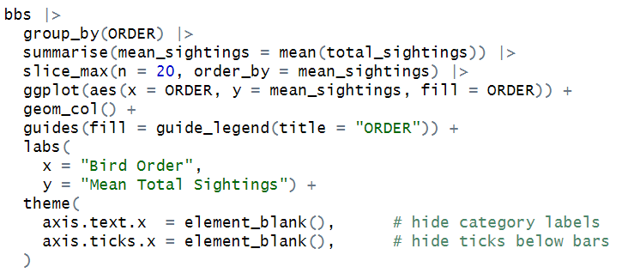
And yielded the following bar chart:
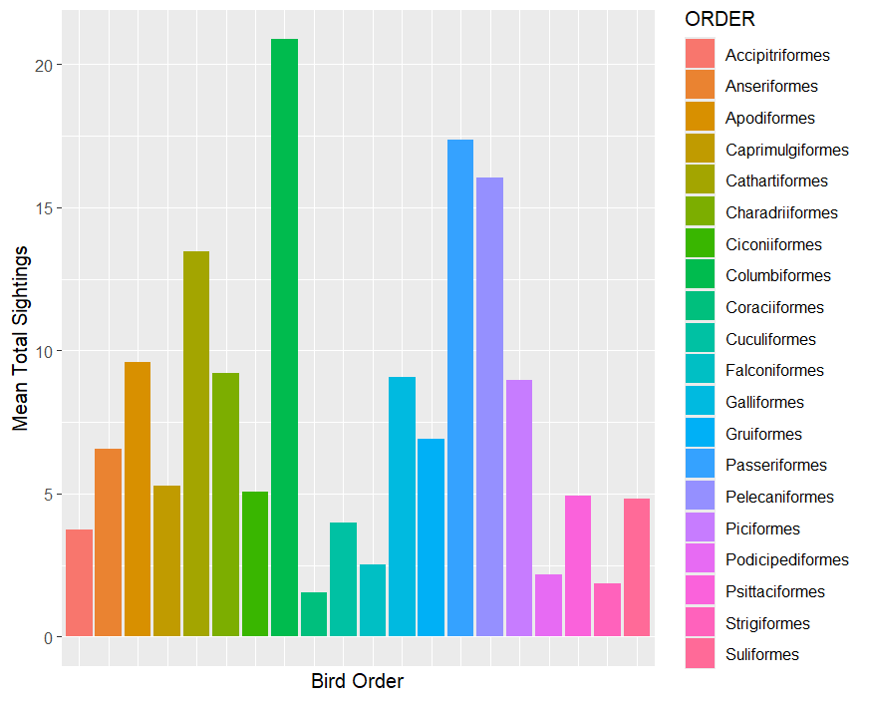
Figure 2: Bar chart looking at the distribution mean total sightings of Bird Orders throughout survey period.
From highest to lowest, the five orders with the highest mean total sightings were: Columbiformes, Passeriformes, Pelecaniformes, Cathartiformes, Apodiformes. Next for Figure 3, a similar bar chart was coded to look at total sightings of each order as opposed to the mean total sightings, the code was:
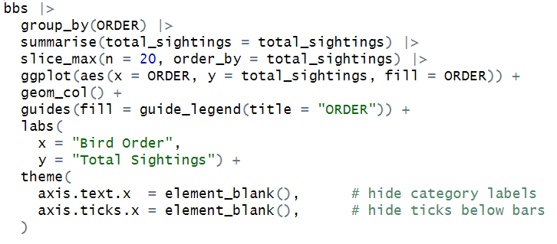
And yielded the following bar chart:
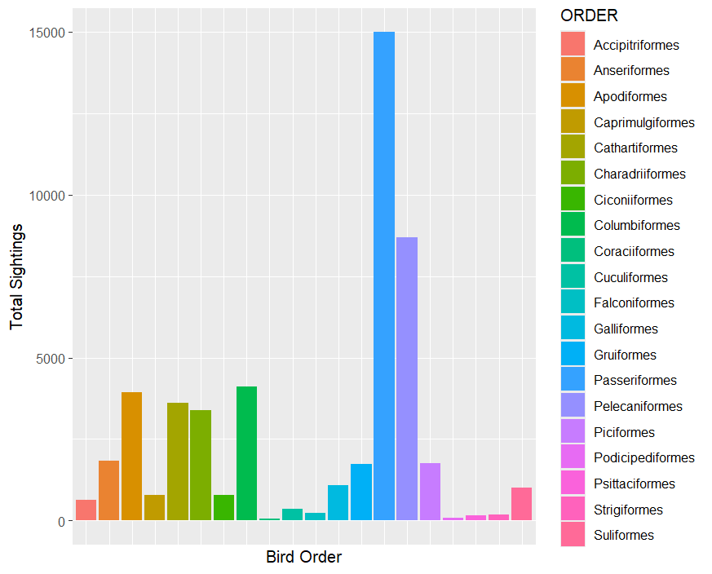
Figure 3: Bar chart showing the distribution of total sightings of each bird order throughout the survey period.
From highest to lowest, the five orders with the highest total sightings were: Passeriformes, Pelecaniformes, Columbiformes, Apodiformes, Cathartiformes. This is interesting, because the same five orders had the highest total sightings and highest mean total sightings, however the hierarchical order of which had the highest value and which had the lowest changed. Passeriformes (song birds) is the order of birds with the largest number of species, so it makes sense that that order had the highest total sightings, however it did not have the highest mean total sightings, which was interesting. The Columbiform (doves and pigeons) order had the highest mean total sightings.
Next, a scatterplot (Figure 4) looked at how mean total species changed over time, and was coded as follows:
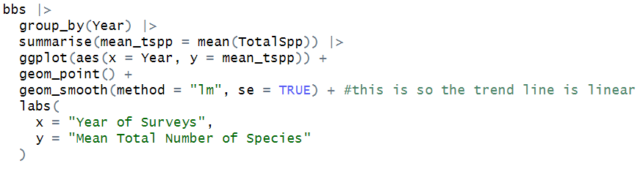
And yielded the following scatter plot:
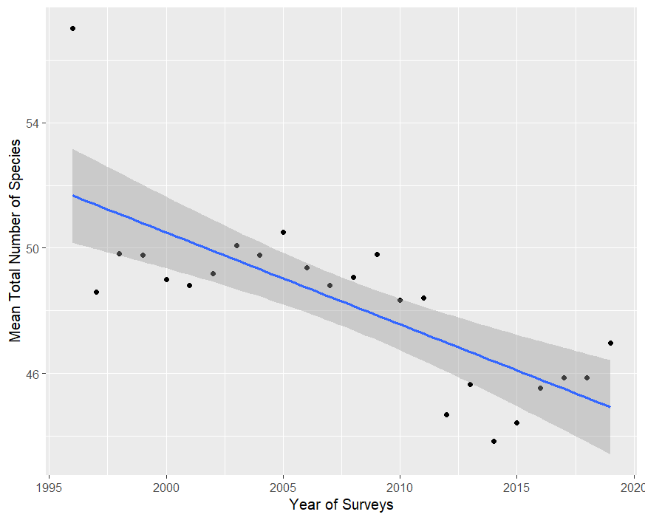
Figure 4: Scatter plot looking at how mean total species changes over time (Year)
A pearson correlation test was ran (akin to that run for all of the following relationships) and yielded a cor value of -0.1526262, suggesting a weak negative correlation (so as the years went on, the mean total sightings of species decreased slightly); however, it had a significant p-value of 2.2e-16, suggesting there is a statistically significant relationship between these two variables. In other words, the total species of birds seen decreased over time. Note: the code for the pearsons test was as follows, and was altered for each graph to account for the appropriate variables:
The next analysis done looked at how MAP affected mean total species (Figure 5). The coding for that scatter plot was:
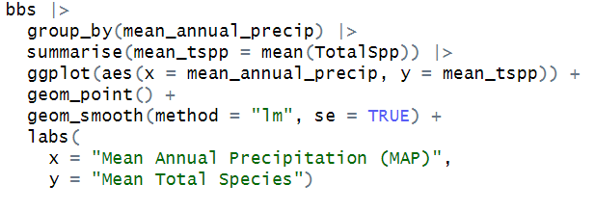
And the output of the code was:
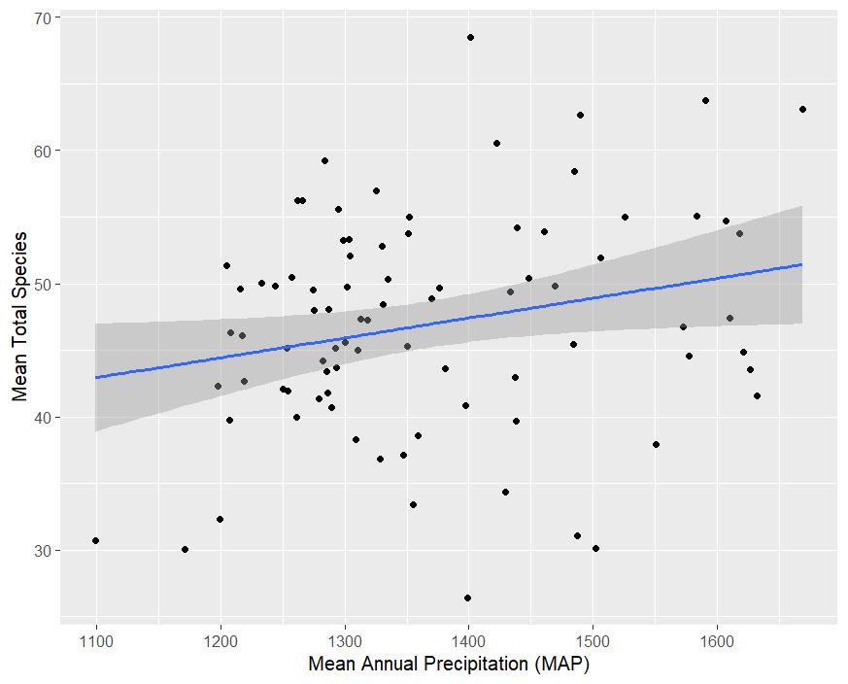
Figure 5: Scatter plot looking at how Mean annual precipitation (MAP) affects mean total species count.
This graph had a correlation value of 0.1885603, suggesting a weak positive correlation, but also had a p-value of 2.2e-16, also suggesting there is a statistically significant relationship between these two variables. So, as MAP increases, mean tspp increases slightly.
Figure 6 looked at how MAT affected mean tspp, the coding for which was as follows:
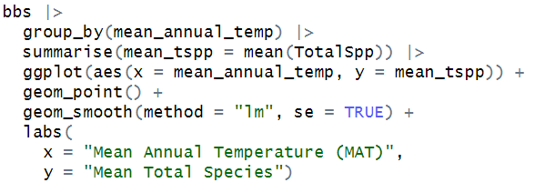
And the graph produced was:
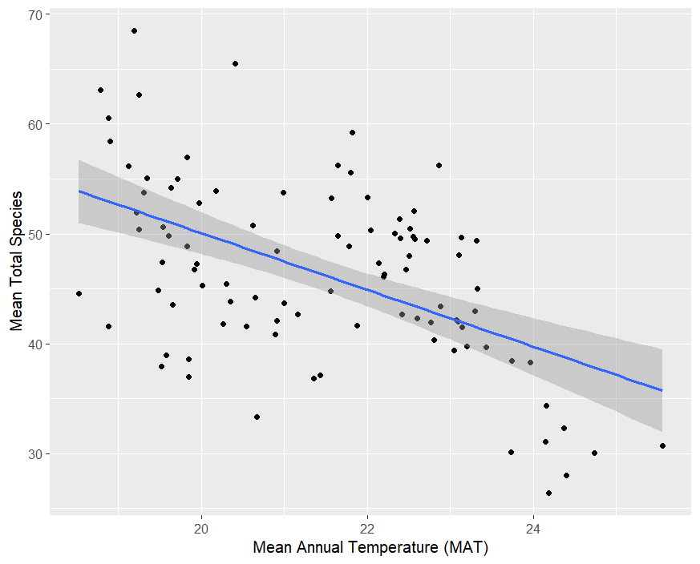
Figure 6: Scatter plot looking at how Mean total species changes with Mean Annual Temperature (MAT)
This graph yielded a correlation value of -0.3760006, suggesting a weak-to-moderate correlation between MAT and mean tspp, but also had a p-value of 2.2e-16, suggesting there is a statistically significant relationship between these two variables. So, as MAT increases, mean tspp decreases.
Figure 7 then looked at the relationship between MAT and MAP, coded as follows:
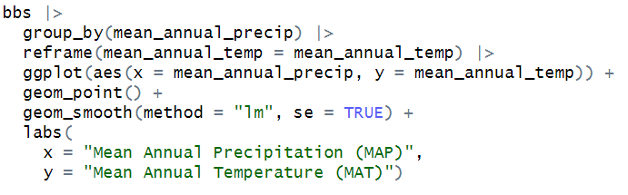
And yielded a graph of:
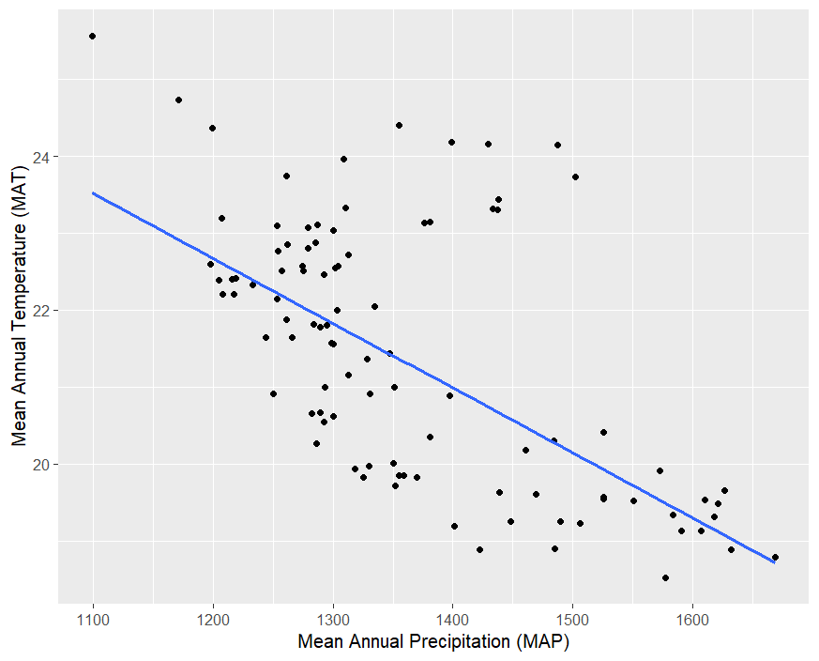
Figure 7: Scatter plot showing the relationship between Mean annual precipitation (MAP) and Mean annual temperature (MAT)
This relationship had a correlation value of -0.6527875, suggesting a moderate-to-strong negative correlation, with a p-value of 2.2e-16, also suggesting a statistically significant relationship between MAT and MAP, in other words, as MAP increases, MAT decreases.
Next, the relationship between fraction built and Mean total species seen was looked at, coded in the following manner:
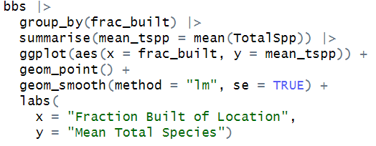
And produced the following scatter plot:
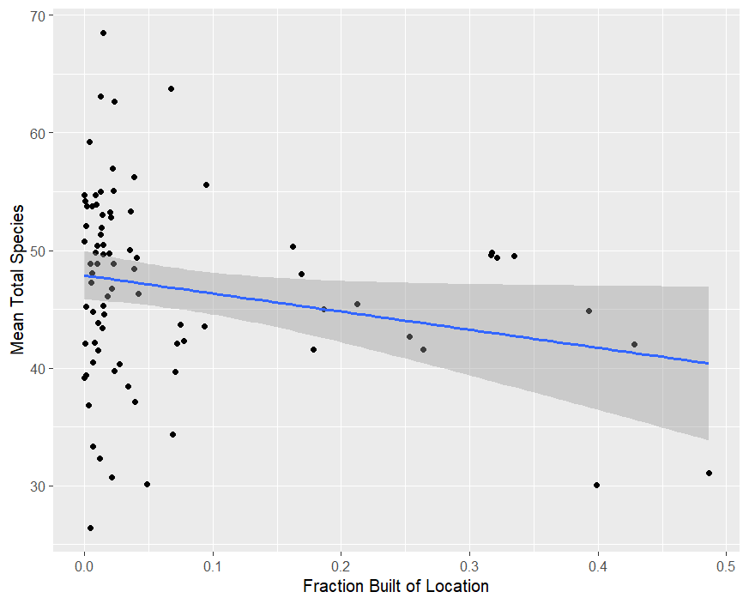
Figure 8: Scatter plot looking at the relationship between fraction built of a given location and the mean total species found.
The correlation value produced was -0.1359886, suggesting a weak negative correlation, but also had the same significant p-value of 2.2e-16, also suggesting there is a statistically significant relationship. So, as fraction built of a location goes up, the mean total species in said location tends to go down.
Finally, the last relationship looked at, was between fraction built and MAT, the code f0or the graph was:
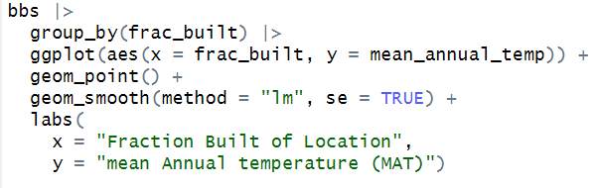
And the graph produced was:
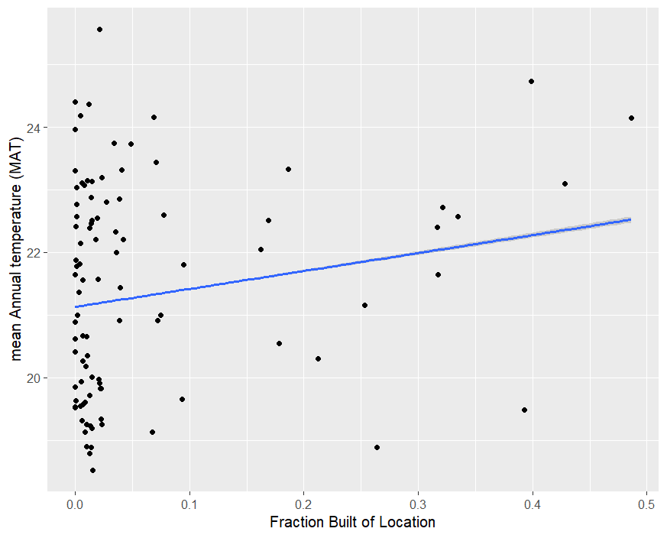
Figure 9: Scatter plot looking at the relationship between fraction built of a location and the Mean annual temperature (MAT) found.
The correlation value found was 0.1829762 suggesting a weak positive correlation, but the p-value was again 2.2e-16 suggesting the relationship is statistically significant. In other words, as the fraction built of a location increases, one would expect the MAT to increase as well.
All of these relationships looked at provide an interesting story. As MAT increases, mean tspp decreases, as Map increases, mean tspp increases, as MAP increases MAT decreases, as fraction built increases mean tspp decreases, and as fraction built increases MAT increases. So, one could infer with this information that as a location has more development, the MAT will increases, which both an increase in MAT and fraction built will decrease the mean tspp, as MAT increases, the MAP will decrease, which will also decrease the mean tspp found, so the model previously looked at suggesting there is an interaction with all of these predictor variables seems to be correct because as one variable changes, the other variables change as well all to encompass the determination of Total species found. This could be expanded on in the future to suggest better urbanization practices to ensure the health of the bird biodiversity in any given location.

Citation:
- Why we need birds (far more than they need us) - BirdLife International
- Ziolkowski Jr., D.J., Lutmerding, M., Aponte, V.I., and Hudson, M-A.R., 2022, North American Breeding Bird Survey Dataset 1966 - 2021: U.S. Geological Survey data release, https://doi.org/10.5066/P97WAZE5.
- The Wildlife Society. (2024, January 8). Humans caused bird extinction throughout history. The Wildlife Society. https://wildlife.org/humans-caused-bird-extinction-throughout-history/
- B. Maitner. (n.d.). FL_BBS.csv [Data set]. In Statistical_ecology_course (repository). GitHub. Retrieved October 14, 2025, from https://github.com/bmaitner/Statistical_ecology_course/blob/main/data/BBS/FL_BBS.csv
- RStudio Team. (2023). RStudio: Integrated Development Environment for R (Version 2023.09.0+463) [Computer software]. Posit Software, PBC. https://posit.co/
- H. Wickham. ggplot2: Elegant Graphics for Data Analysis. Springer-Verlag New York, 2016.
- Bolker B, R Development Core Team (2023). _bbmle: Tools for General Maximum
Likelihood Estimation_. doi:10.32614/CRAN.package.bbmle <https://doi.org/10.32614/CRAN.package.bbmle>, R package version 1.0.25.1, <https://CRAN.R-project.org/package=bbmle>.
- Wickham H, Vaughan D, Girlich M (2024). _tidyr: Tidy Messy Data_.
doi:10.32614/CRAN.package.tidyr <https://doi.org/10.32614/CRAN.package.tidyr>, R
package version 1.3.1, <https://CRAN.R-project.org/package=tidyr>.
- Wickham H, Hester J, Bryan J (2024). _readr: Read Rectangular Text Data_.
doi:10.32614/CRAN.package.readr <https://doi.org/10.32614/CRAN.package.readr>, R
package version 2.1.5, <https://CRAN.R-project.org/package=readr>.
- Wickham H (2007). “Reshaping data with the reshape package.” _Journal of Statistical
Software_, *21*(12). <https://www.jstatsoft.org/v21/i12/>.
- Warnes G, Bolker B, Bonebakker L, Gentleman R, Huber W, Liaw A, Lumley T, Maechler
M, Magnusson A, Moeller S, Schwartz M, Venables B, Galili T (2024). _gplots: Various
R Programming Tools for Plotting Data_. doi:10.32614/CRAN.package.gplots
<https://doi.org/10.32614/CRAN.package.gplots>, R package version 3.2.0,
<https://CRAN.R-project.org/package=gplots>.
- Lemon, J. (2006) Plotrix: a package in the red light district of R. R-News, 6(4): 8-12.
- Wickham H, François R, Henry L, Müller K, Vaughan D (2023). _dplyr: A Grammar of
Data Manipulation_. doi:10.32614/CRAN.package.dplyr
<https://doi.org/10.32614/CRAN.package.dplyr>, R package version 1.1.4,
<https://CRAN.R-project.org/package=dplyr>.
- Sarkar D (2008). _Lattice: Multivariate Data Visualization with R_. Springer, New
York. ISBN 978-0-387-75968-5, <http://lmdvr.r-forge.r-project.org>.
- Meyer D, Dimitriadou E, Hornik K, Weingessel A, Leisch F (2024). _e1071: Misc
Functions of the Department of Statistics, Probability Theory Group (Formerly:
E1071), TU Wien_. doi:10.32614/CRAN.package.e1071
<https://doi.org/10.32614/CRAN.package.e1071>, R package version 1.7-16,
<https://CRAN.R-project.org/package=e1071>.
- OpenAI. (2025). ChatGPT (GPT-5) [Large language model]. OpenAI. https://chat.openai.com/
- Bolker, Benjamin M.. Ecological Models and Data in R, Princeton University Press, 2008. ProQuest Ebook Central,
http://ebookcentral.proquest.com/lib/usf/detail.action?docID=765289.
Created from usf on 2025-09-03 19:29:09.

